Power Network Using Graph, BFS and Kruskal’s Algorithm

Problem statement:-

Develop a C++ program to represent power substations as vertices and power lines as weighted edges. Apply BFS or DFS to check reachability from a selected substation, then apply Kruskal's algorithm to calculate the minimum spanning tree cost when the graph is connected.

Objectives:
- To represent a power network using a graph data structure.
- To represent substations as vertices and power lines as weighted edges.
- To implement BFS to check the reachability of substations.
- To determine whether the power network is connected or disconnected.
- To implement Kruskal’s algorithm to find the Minimum Spanning Tree.
- To calculate the minimum total cost of connecting all substations.
- To display an appropriate message when an MST is not possible.

Algorithm:-
  - Start the program.
  - Input the number of substations and power lines.
  - Create a graph using an adjacency list.
  - Input the endpoints and cost of each power line.
  - Select a starting substation.
  - Apply BFS to visit all reachable substations.
  - Count the number of visited substations.
  - If all substations are visited, declare the network connected.
  - Sort all power lines in ascending order of cost.
  - Apply Kruskal’s algorithm to select the minimum-cost edges without forming cycles.
  - Calculate and display the MST cost.
  - If the graph is disconnected, display that an MST does not exist.
  - Stop the program.

Flowchart:-
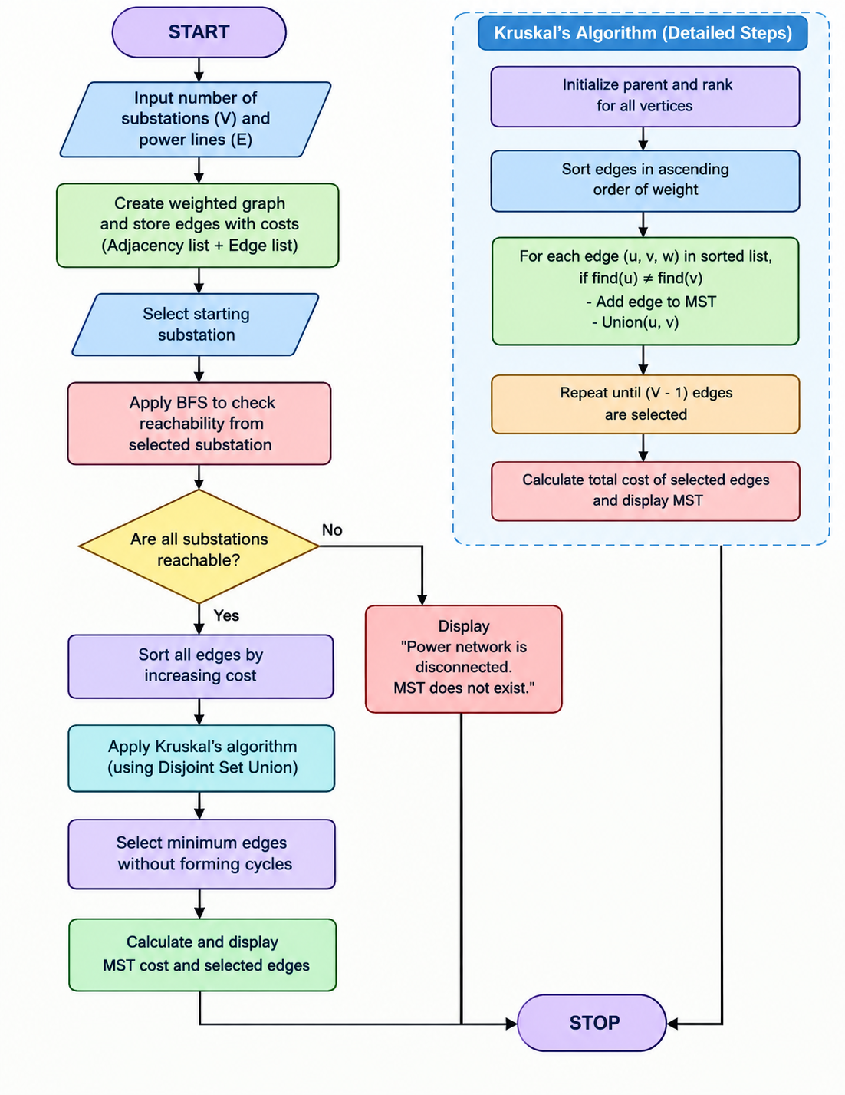

Code:-
#include <iostream>
#include <vector>
#include <queue>
#include <algorithm>
using namespace std;
struct Edge
{
int u, v, weight;
};

bool compareEdges(Edge a, Edge b)
{
return a.weight < b.weight;
}

class PowerNetwork
{
int n, m;
vector<Edge> edges;
vector<vector<int> > adj;

int findParent(vector<int>& parent, int x)
{
if (parent[x] == x)
return x;

parent[x] = findParent(parent, parent[x]);
return parent[x];
}

bool unite(vector<int>& parent, vector<int>& rankSet,
int u, int v)
{
u = findParent(parent, u);
v = findParent(parent, v);

if (u == v)
return false;

if (rankSet[u] < rankSet[v])
parent[u] = v;
else if (rankSet[u] > rankSet[v])
parent[v] = u;
else
{
parent[v] = u;
rankSet[u]++;
}

return true;
}
public:
PowerNetwork()
{
n = 0;
m = 0;
}
bool createNetwork()
{
cout << "Enter number of substations: ";
cin >> n;
if (n <= 0)
{
cout << "Invalid number of substations.\n";
return false;
}
cout << "Enter number of power lines: ";
cin >> m;

if (m < 0)
{
cout << "Invalid number of power lines.\n";
return false;
}

adj.resize(n);

cout << "\nEnter power lines as: "
<< "substation1 substation2 cost\n";

for (int i = 0; i < m; i++)
{
Edge e;

cout << "Edge " << i + 1 << ": ";
cin >> e.u >> e.v >> e.weight;

if (e.u < 0 || e.u >= n ||
e.v < 0 || e.v >= n ||
e.u == e.v || e.weight < 0)
{
cout << "Invalid edge. Try again.\n";
i--;
continue;
}

edges.push_back(e);
adj[e.u].push_back(e.v);
adj[e.v].push_back(e.u);
}

return true;
}

bool BFS(int start)
{
if (start < 0 || start >= n)
{
cout << "Invalid starting substation.\n";
return false;
}

vector<bool> visited(n, false);
queue<int> q;
int count = 0;

visited[start] = true;
q.push(start);

cout << "\nBFS traversal: ";

while (!q.empty())
{
int u = q.front();
q.pop();

cout << u << " ";
count++;

for (int i = 0; i < (int)adj[u].size(); i++)
{
int v = adj[u][i];

if (!visited[v])
{
visited[v] = true;
q.push(v);
}
}
}

cout << "\nReachable substations: "
<< count << " out of " << n << endl;
if (count == n)
{
cout << "Power network is connected.\n";
return true;
}
cout << "Power network is disconnected.\n";
return false;
}
void kruskal()
{
sort(edges.begin(), edges.end(), compareEdges);

vector<int> parent(n);
vector<int> rankSet(n, 0);
for (int i = 0; i < n; i++)
parent[i] = i;
int totalCost = 0;
int selected = 0;
cout << "\nEdges selected by Kruskal:\n";
for (int i = 0;
i < (int)edges.size() && selected < n - 1;
i++)
{
Edge e = edges[i];

if (unite(parent, rankSet, e.u, e.v))
{
cout << e.u << " -- " << e.v
<< " : " << e.weight << endl;

totalCost += e.weight;
selected++;
}
}

if (selected == n - 1)
cout << "Minimum Spanning Tree cost = "
<< totalCost << endl;
else
cout << "MST does not exist because "
<< "the graph is disconnected.\n";
}
};

int main()
{
PowerNetwork p;
int start;
if (!p.createNetwork())
return 0;
cout << "\nEnter starting substation (0 to n-1): ";
cin >> start;
cout << "\n--- BFS Reachability ---\n";
bool connected = p.BFS(start);
if (connected)
{
cout << "\n--- Kruskal's Algorithm ---\n";
p.kruskal();
}
else
{
cout << "\nMST cost is not calculated because "
<< "the network is disconnected or the "
<< "starting substation is invalid.\n";
}

return 0;
}

Output: 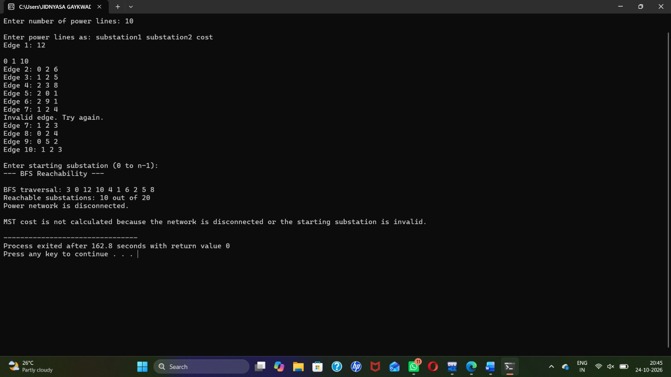

Conclusion:
The program represents an electrical power network using a weighted graph. BFS identifies reachable substations and verifies connectivity, while Kruskal’s algorithm determines the minimum cost required to connect all substations without creating cycles. This approach can help model cost-efficient power network planning.

